In the mirCLIP data analysis, genes exhibiting a fold change above 2 and at least one match in the 3’UTR of mRNAs totaled more than 1000 targets. This abundance of genes rendered gene enrichment analysis challenging, as it is recommended to have a more manageable number of genes, ideally between 15 and 500, for effective analysis (https://www.gsea-msigdb.org/).

To address this issue, the fold change threshold was increased to 4. This adjustment resulted in a reduction in the number of genes to 207, making further analysis more feasible and ensuring a more focused examination of gene expression patterns and regulatory mechanisms.

Prior to conducting the gene enrichment analysis, the utilization of David 2021 version 2023q4 identified a set of genes directly associated with adhesion, as "adhesion" was among the list of Gene Ontology (GO) term Biological Processes. This preliminary identification provided valuable insight into the specific genes involved in adhesion-related processes, laying the groundwork for a more targeted and focused gene enrichment analysis.

Table . Gene in 4x fold change that target adhesion

|  |  |  |
| --- | --- | --- |
| **ID** | **Gene Name** | **Fold Change** |
| BCL2L11 | BCL2 like 11(BCL2L11) | **4.710346741** |
| FERMT2 | FERM domain containing kindlin 2(FERMT2) | **4.210001445** |
| S100A11 | S100 calcium binding protein A11(S100A11) | **5.445400077** |
| CLDN4 | claudin 4(CLDN4) | **4.650374662** |
| COL1A1 | collagen type I alpha 1 chain(COL1A1) | **5.568596313** |
| INPPL1 | inositol polyphosphate phosphatase like 1(INPPL1) | **4.347005122** |
| NECTIN4 | nectin cell adhesion molecule 4(NECTIN4) | **4.266390305** |
| PDGFB | platelet derived growth factor subunit B(PDGFB) | **5.294020144** |
| RGMB | repulsive guidance molecule BMP co-receptor b(RGMB) | **4.058232689** |
| SPRY4 | sprouty RTK signaling antagonist 4(SPRY4) | **4.631111124** |
| STX3 | syntaxin 3(STX3) | **4.680558382** |

Further analysis is needed to understand the pathways involved

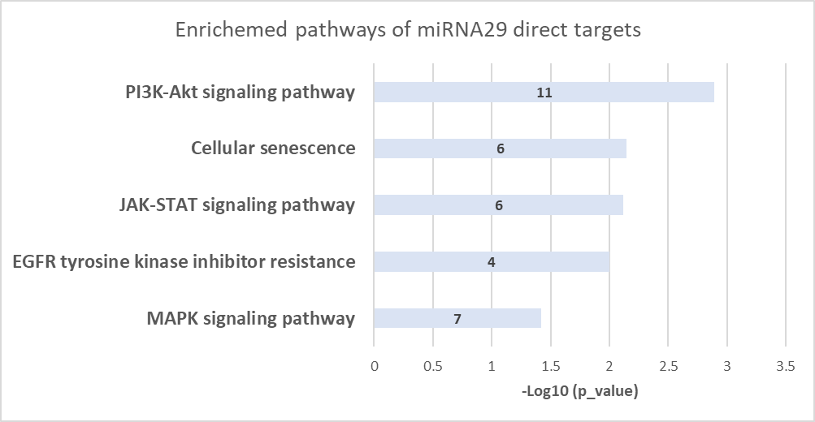

**Figure. Direct targets of miRNA 29 affect signaling pathway and gene proliferation. KEGG enriched pathways obtained using the genes with a fold change higher than 4.**

Write down mRNAs

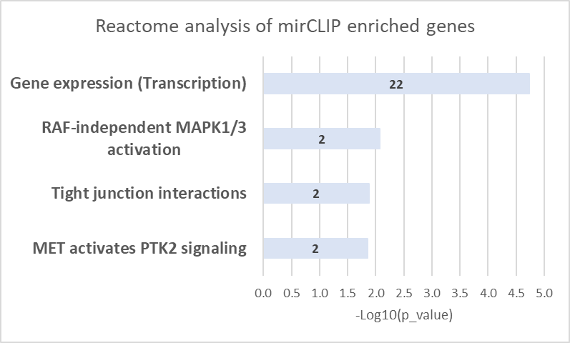

**Figure. MiRNA29 direct targets were found to impact transcription and adhesion.** The 100 genes with the highest fold change were chosen to prioritize the selection of miRNA 29 targets. Notably, among these genes, the last two are associated with adhesion processes. Despite this, the most significant increase observed still pertains to transcriptional regulation, suggesting a substantial impact of miRNA29 on gene expression regulation. ** Pathway analysis unveiled the influence of miRNA29's direct targets on mRNA stability. Nevertheless, it's important to acknowledge the possibility of noise signals contributing to these findings.

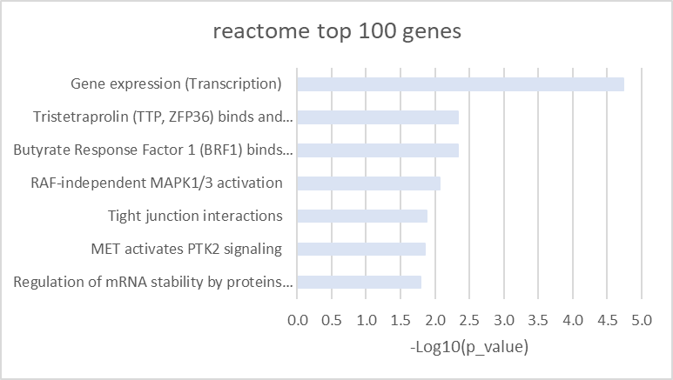

## Analysis of common mRNAs in the mirCLIP data and gene expression in fast adhesion with the presence of the miRNA29 inhibitor (fast_abc)

66 mRNAs exhibited common upregulation in fast adhesion keratinocytes with the presence of the miRNA29 inhibitor (log2(foldChange) > 0.5, equivalent to 1.41 fold change) and in mirCLIP mRNAs with a fold change above 2.

The pathways influenced by this upregulation primarily included responses to cytokines, signaling cascades, and proliferation.

However, upon raising the mirCLIP fold change threshold to 4, only 12 mRNAs remained common between the two datasets.

Despite this, it was evident that miRNA29 targeted mRNAs associated with cell adhesion and growth. Notably, these were the only categories with more than one mRNA per category.

|  |  |  |  |  |  |
| --- | --- | --- | --- | --- | --- |
| **geneSet** | **description** | **N of mRNAs** | **pValue** | **mRNAs** | **Average fold change** |
| R-HSA-446728 | Cell junction organization | 2 | 0.001991 | CLDN4;FERMT2 | 4.6 |

|  |  |  |  |  |  |
| --- | --- | --- | --- | --- | --- |
| **geneSet** | **description** | **overlap** | **pValue** | **mRNAs** | **Average fold change** |
| GO:0040007 | growth | 5 | 2.18E-04 | BCL2L11;PIM1;SEMA7A;SESN2;STK40 | 8.5 |

Sema7a and STX40 presented a Mir-CLIP fold change even above 10

CLDN4, an adhesive molecule, has been reported to enhance tight junctions (Sakamoto et al., 2024; Minowa et al., 2021).

FERMt2, also known as kindlin 2, is expressed in both keratinocytes and fibroblasts. In fibroblasts, it enhances focal adhesion during wound healing (He et al., 2011). In keratinocytes, FERMT2 is essential for motility and intercellular adhesion (Simpson et al., 2011).

Sema7a has been shown to promote attachment and spreading in fibroblasts. Although expressed in keratinocytes as well, its role remains unclear (Upadhyay et al., 2021).

Sest2 induces the PI3K/AKT pathway, thereby promoting wound healing by enhancing keratinocyte proliferation and migration (Wang et al., 2023).

*He, Y., Esser, P., Heinemann, A., Bruckner-Tuderman, L., & Has, C. (2011). Kindlin-1 and -2 Have Overlapping Functions in Epithelial Cells. The American Journal of Pathology, 178(3), 975–982.* [*https://doi.org/10.1016/j.ajpath.2010.11.053*](https://doi.org/10.1016/j.ajpath.2010.11.053)

*Minowa, E., Kurashige, Y., Syed Taufiqul Islam, Yoshida, K., Sakakibara, S., Okada, Y., Fujita, Y., Dembereldorj Bolortsetseg, Murai, Y., & Masato Saitoh. (2021). Increased integrity of cell–cell junctions accompanied by increased expression of claudin 4 in keratinocytes stimulated with vitamin D3. Medical Molecular Morphology, 54(4), 346–355.* [*https://doi.org/10.1007/s00795-021-00299-1*](https://doi.org/10.1007/s00795-021-00299-1)

*Sakamoto, H., Nishikawa, M., & Yamada, S. (2024). Development of tight junction-strengthening compounds using a high-throughput screening system to evaluate cell surface-localized claudin-1 in keratinocytes. Scientific Reports, 14(1), 3312.* [*https://doi.org/10.1038/s41598-024-53649-1*](https://doi.org/10.1038/s41598-024-53649-1)

*Simpson, C. L., Patel, D. M., & Green, K. J. (2011). Deconstructing the skin: cytoarchitectural determinants of epidermal morphogenesis. Nature Reviews Molecular Cell Biology, 12(9), 565–580.* [*https://doi.org/10.1038/nrm3175*](https://doi.org/10.1038/nrm3175)

*Upadhyay, P. R., Ho, T., & Abdel‐Malek, Z. A. (2021). Participation of keratinocyte‐ and fibroblast‐derived factors in melanocyte homeostasis, the response to UV, and pigmentary disorders. Pigment Cell & Melanoma Research, 34(4), 762–776. https://doi.org/10.1111/pcmr.12985*

*Wang, K., Shen, K., Han, F., Bai, X., Fang, Z., Jia, Y., Zhang, J., Li, Y., Cai, W., Wang, X., Luo, L., Guo, K., Wang, H., Yang, X., Wang, H., & Hu, D. (2023). Activation of Sestrin2 accelerates deep second-degree burn wound healing through PI3K/AKT pathway. Archives of Biochemistry and Biophysics, 743, 109645. https://doi.org/10.1016/j.abb.2023.109645*